For different time:

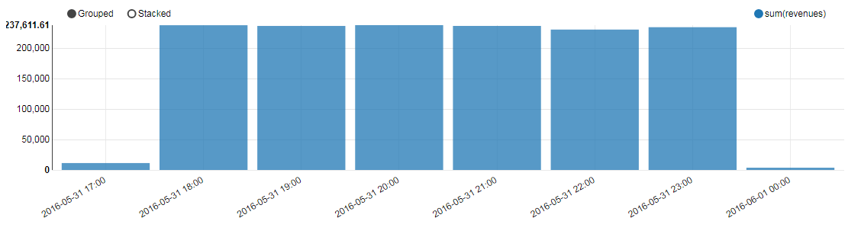

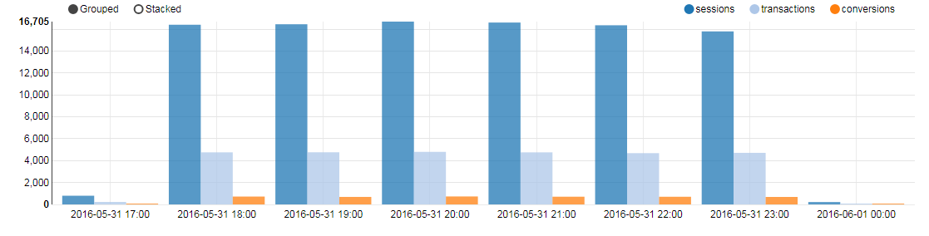

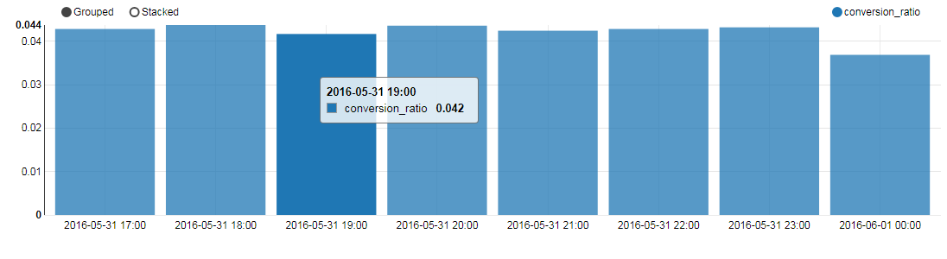

We can see that from 18:00 to 23:00 the total revenues, transactions, conversions and sessions are significantly higher than other time periods. From 20:00 -21:00 is the highest.

No obvious difference in conversion/session is found.

For different sites (x-axis is siteId):

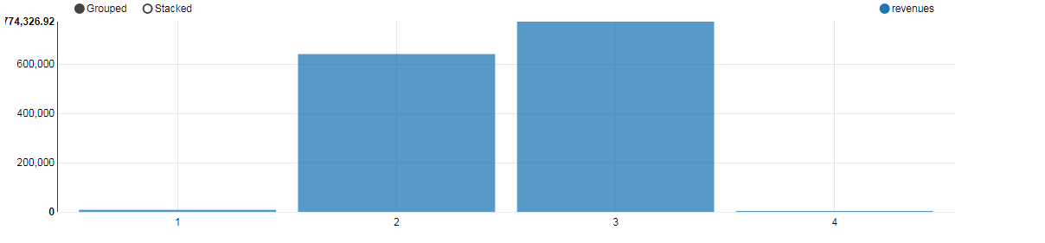

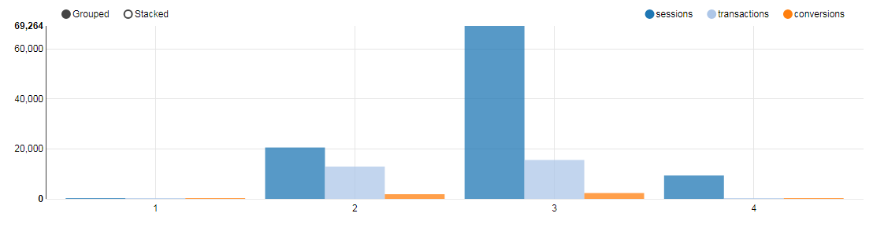

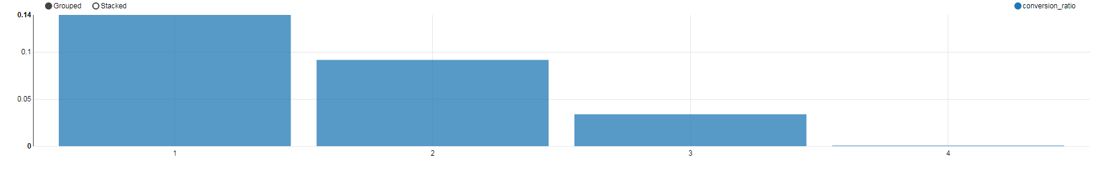

Site 2 and 3 are better at getting sessions (visits) and revenues. Although conversion_ratio is higher in site 1, probably meaning site needs to be visited more.

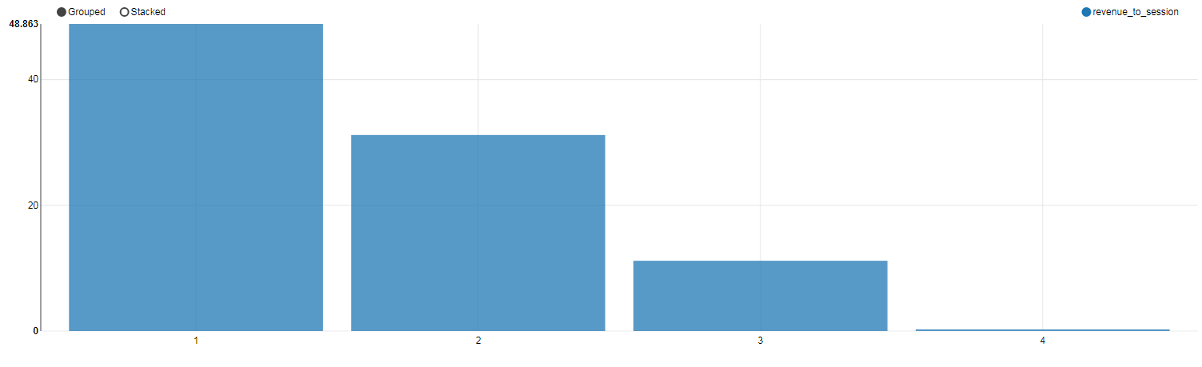

This is revenue per session vs. siteId, which further proves that site1 is better at attracting purchasing but needs more visits. Site4 needs to be substituted.

For different ads:

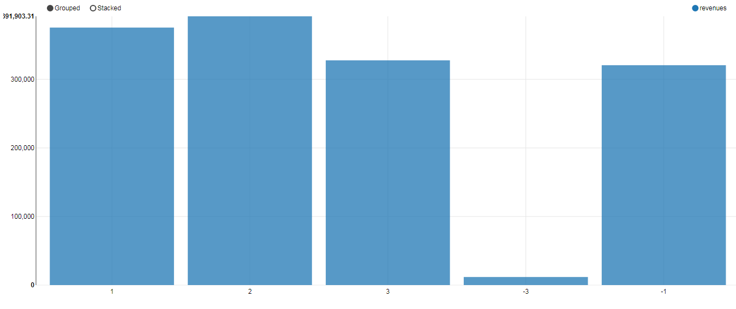

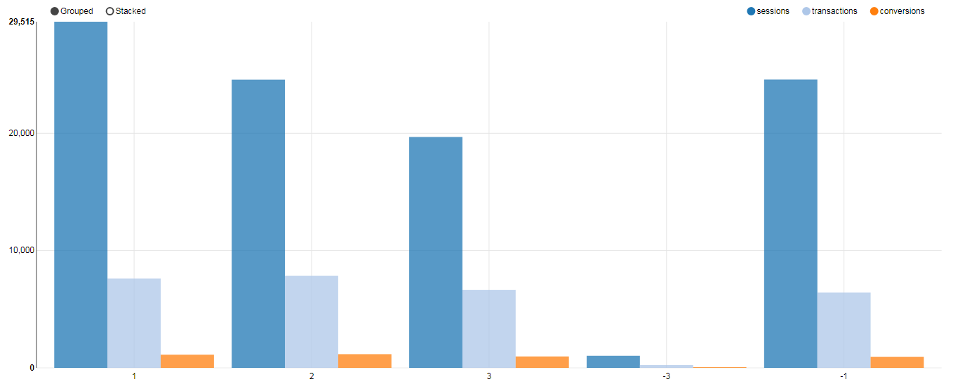

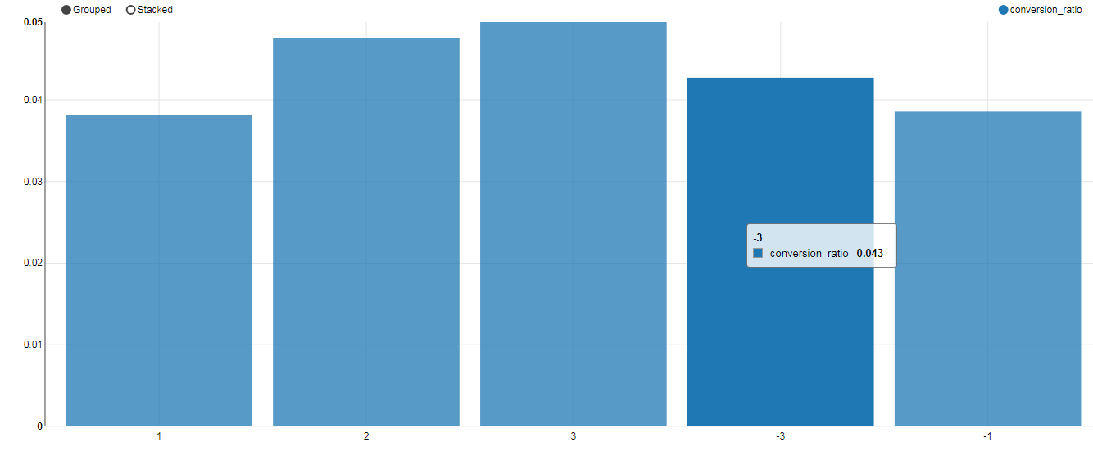

**-3** here means the orders that do not have info on ad (explained in the data quality report, those cases are rare (1%)).

So we see that ad1 are most visited. On revenues, ad2 > ad1 > ad3 > ad-1.

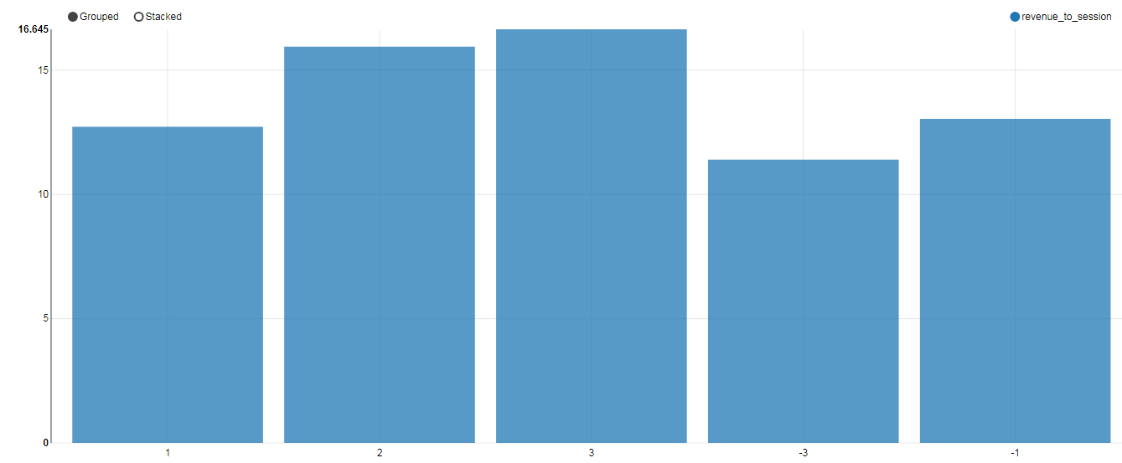

This graph is revenue per session, we found that ad3 is the best to acquire revenues but needs more visits.

Similar analysis and visualizations can be done to “browsers”, “source”  
and “features”......